

HOUSE PRICE PREDICTION USING PYTHON

Submitted by

Dharshan R(231801133)

Ramesh M(231801134)

Ramya A(231801135)

Ramya devi K(231801136)

Fundamentals of Machine learning

Department of Artificial Intelligence and Data Science

**Rajalakshmi Engineering College, Thandalam**



BONAFIDE CERTIFICATE

NAME………………………………………………………………………………...............

ACADEMIC YEAR………………SEMESTER………….BRANCH………………………..

UNIVERSITY REGISTER No.

Certified that this is the bonafide record of work done by the above students in the Mini Project titled **"HOUSE PRICE PREDICTION USING PYTHON"** in the subject **AI23331 – FUNDAMENTALS OF MACHINE LEARNING** during the year 2024 - 2025.

**Signature of Faculty – in – Charge**

**Submitted for the Practical Examination held on**

**Internal Examiner External Examiner**

# TABLE OF CONTENTS

|  |  |  |
| --- | --- | --- |
| **S.No** | **Chapter** | **Page Number** |
| 1. | ABSTRACT | iv |
| 2. | INTRODUCTION | 1 |
| 3. | LITERATURE SURVEY | 4 |
| 4. | MODEL ARCHITECTURE | 7 |
| 5. | IMPLEMENTATION | 10 |
| 6. | RESULT | 21 |
| 7. | CONCLUSION | 25 |
| 8. | REFERENCES | 26 |

**ABSTRACT**

This project focuses on predicting residential property prices, a crucial component in fields like real estate and financial planning. The goal is to develop a reliable house price prediction model using Linear Regression, known for its interpretability and efficiency in handling regression tasks. By leveraging a standardized dataset containing various housing attributes (e.g., location, size, number of bedrooms), we preprocess the data through cleaning, normalization, and feature selection to optimize it for model training. The approach revolves around Linear Regression, chosen for its balance between simplicity and predictive power in cases where input-output relationships tend toward linearity.Our model's performance is rigorously evaluated using common regression metrics, such as Mean Absolute Error (MAE) and Mean Squared Error (MSE), ensuring accuracy and practical relevance for real-world applications. The project's scope also includes a comparative analysis with other common regression algorithms, such as Decision Trees and K-Nearest Neighbors, benchmarking their performance to validate the choice of Linear Regression for this prediction task. The entire project is meticulously documented, from initial data processing through model training, evaluation, and testing, allowing for reproducibility and transparency. Additionally, we provide insights into the effectiveness of Linear Regression in price prediction and suggest avenues for further research in real estate forecasting and predictive analytics.

# 

**CHAPTER 1**

**INTRODUCTION**

House price prediction is a vital application in predictive analytics, impacting real estate, finance, and investment industries. Accurate and reliable predictions support decisions around mortgage approvals, property valuations, and market trend analyses. With an increasing shift toward data-driven insights, demand is growing for efficient models capable of delivering precise, consistent results. This project focuses on developing a straightforward yet effective house price prediction model using Linear Regression, a powerful algorithm for handling continuous values. The model is designed to capture the relationship between essential property features (e.g., location, size, amenities) and pricing to ensure broad applicability across various property types.

Our approach begins with the acquisition of a standardized housing dataset, followed by a series of preprocessing steps, such as handling missing values, normalizing data, and encoding categorical variables, to optimize the dataset for model training. Through careful data processing, we aim to enhance model accuracy and make the learning process more effective. By systematically tuning the model, including feature selection, we focus on balancing accuracy and interpretability while avoiding overfitting.

To further validate our approach, we conduct a comparative analysis, benchmarking Linear Regression against other algorithms such as Decision Trees and Random Forests. This helps assess its suitability for predicting housing prices, offering valuable insights into both its strengths and limitations. Comprehensive documentation ensures replicability, covering each stage from data preparation to model evaluation and insights on real estate forecasting.

# 

# ALGORITHM USED

The Linear Regression algorithm used in this project is a widely adopted and interpretable approach for predicting continuous values, well-suited to the problem of house price prediction. Linear Regression finds the optimal fit line (hyperplane) by minimizing the sum of squared residuals between actual and predicted values, capturing the linear relationships between housing attributes and prices. To improve performance, we tune parameters like feature inclusion and data transformation techniques. Evaluating the model through metrics such as Mean Absolute Error (MAE) and R-squared allows us to quantify accuracy and reliability. Additionally, cross-validation is used to ensure robustness across diverse data subsets.

The results demonstrate Linear Regression’s ability to produce reliable predictions, supporting its use in real estate analytics and forecasting. By balancing accuracy, efficiency, and simplicity, this project showcases Linear Regression’s effectiveness in predictive modeling for the housing market.

Overall, Linear Regression proves to be a powerful yet interpretable tool for house price prediction, balancing simplicity with predictive performance. Through careful preprocessing, feature engineering, and parameter tuning, the model achieves a level of accuracy that supports practical application in real estate forecasting. The project’s transparent documentation and modular structure allow for easy adaptation and potential improvements, setting the stage for future advancements in predictive real estate modeling.

# CHAPTER 2

# LITERATURE SURVEY

The prediction of house prices has emerged as a significant application within the field of machine learning, addressing both the commercial and academic need for accurate property valuation models. This domain leverages various machine learning techniques to analyze a wide range of features, including location, area, number of bedrooms, and other physical and economic factors. This literature survey delves into the contributions of seminal studies on house price prediction, highlighting the effectiveness of algorithms like Linear Regression, Decision Trees, Support Vector Machines, and Neural Networks, and examining the data preprocessing and feature engineering methods that enhance prediction accuracy.

### *Early Work on Predictive Modeling in Real Estate*

The application of machine learning to real estate pricing can be traced back to early statistical models that aimed to capture the linear relationships between property features and prices. Linear Regression, a widely used statistical approach introduced by Gauss and Legendre in the early 19th century, has formed the foundation of price prediction models due to its simplicity and interpretability. Early models primarily relied on hedonic pricing methods, where housing prices were modeled as a function of intrinsic attributes (such as size and age) and extrinsic attributes (such as location and proximity to amenities). Studies by Rosen (1974) and Muth (1969) laid the groundwork for the development of hedonic regression models, which have been enhanced over time by incorporating more variables and leveraging modern computational power for more complex data analysis.

### *Rise of Machine Learning Algorithms for House Price Prediction*

The introduction of more advanced machine learning algorithms has allowed researchers to move beyond simple linear relationships and consider non-linear interactions between features. Decision Trees and Support Vector Machines (SVMs), popularized by Breiman et al. (1984) and Cortes and Vapnik (1995) respectively, provided early non-linear models that could capture complex feature interactions in house price prediction. Decision Trees and their ensemble extensions, such as Random Forests, have been particularly favored for their interpretability and robustness, as they create models that are easily understood by breaking down decisions in a hierarchical, rule-based structure.

For example, the study by Park and Bae (2015) on house price prediction in urban markets demonstrated the effectiveness of Decision Trees in capturing complex relationships between socio-economic factors and housing prices. Similarly, SVMs were explored by Harris and Ho (2007) for predicting property values, where they observed that kernel functions, like Radial Basis Function (RBF), could significantly improve prediction accuracy by allowing the model to project data into higher dimensions, thus capturing non-linear dependencies.

### *Comparative Analyses of Prediction Models*

Several comparative studies have evaluated the performance of different machine learning algorithms for house price prediction. For instance, a study by Ahmed and Moustafa (2019) compared Linear Regression, Decision Trees, SVMs, and Neural Networks, concluding that while Neural Networks generally outperform simpler models in terms of accuracy, Linear Regression remains valuable for its interpretability, especially in markets where linear relationships predominate. These comparative analyses underscore the importance of choosing a model that aligns with the specific data characteristics and the interpretability requirements of the application.

In another study, Wang et al. (2021) examined the scalability of Random Forests and Gradient Boosting Machines for large-scale property data, finding that ensemble methods provide robust performance and are less sensitive to noise than individual models like Decision Trees. They found that, while SVMs can achieve high accuracy, they tend to be more computationally expensive when applied to large datasets. Ensemble methods, with their capability to aggregate predictions from multiple weak learners, were found to be particularly advantageous for large, diverse datasets.

### *Challenges and Future Directions*

While significant progress has been made, several challenges remain in the field of house price prediction. Handling heterogeneous data from multiple sources, such as economic indicators, property listings, and satellite images, requires models capable of integrating diverse data types. The issue of overfitting is also prominent, particularly when applying complex models like deep neural networks to limited datasets. Researchers are increasingly exploring regularization techniques, such as dropout in neural networks, to improve generalization, as shown in studies by Srivastava et al. (2014).

Future research directions may involve the integration of machine learning models with geospatial analysis tools to improve location-based predictions, as suggested by Lam and Chung (2020). Additionally, explainable AI (XAI) techniques are gaining traction, enabling stakeholders to interpret model predictions and understand the factors driving price variations. This is especially valuable in real estate, where model transparency and trustworthiness are crucial.

Emerging areas, such as hybrid models that combine machine learning with econometric approaches, are also being explored to leverage the strengths of both fields. For instance, Pan and Xu (2022) proposed a hybrid model combining hedonic regression with neural networks, achieving improved interpretability while maintaining high prediction accuracy. Further exploration of reinforcement learning in dynamic pricing and auction-based real estate markets could also hold promise for adaptive pricing strategies.

# 

# CHAPTER-3

# MODEL ARCHITECTURE

# 

***Model Architecture for House Price Prediction System***

The house price prediction system is designed to capture relationships between various factors that affect property values, including location, size, age, and nearby amenities. This model balances interpretability and computational efficiency and is structured *around several key components.*

### *Data Preprocessing and Transformation*

Preprocessing ensures data consistency, handling missing values, encoding categorical variables, and scaling features for effective model input. Missing data is managed through imputation techniques, while categorical variables are transformed using encoding methods like one-hot or target encoding. Feature scaling, such as standardization, is applied to align the feature scales, improving model performance.

### *Feature Engineering and Selection*

Feature engineering captures relevant information and reduces data complexity. Interaction terms between features (e.g., location and size) add predictive power, and dimensionality reduction methods like PCA and RFE streamline the model. Feature selection techniques, including correlation analysis and feature importance, are used to retain impactful features and improve interpretability.

### *Model Selection and Training*

Models are chosen based on their ability to capture the non-linear relationships typical in real estate data. Linear Regression provides interpretability, while Decision Tree-based models (e.g., Random Forests, Gradient Boosting Machines) handle complex feature interactions. Support Vector Machines and Neural Networks are also considered for their performance with non-linear data. Each model’s hyperparameters are fine-tuned through methods like Grid Search, with regularization techniques applied to avoid overfitting.

### *Prediction and Evaluation*

After training, models are evaluated using test data to measure their accuracy. Metrics such as Mean Absolute Error (MAE), Root Mean Square Error (RMSE), and R-squared (R²) assess predictive performance. Interpretation tools like SHAP and LIME enhance transparency, providing insights into feature contributions for stakeholder trust.

### *Overall Effectiveness*

The architecture provides accurate predictions with a focus on ease of deployment and interpretability, making it suitable for diverse real estate markets. Combining data preprocessing, feature engineering, and model tuning, this system achieves reliable property value estimates. Future improvements could integrate multi-modal data for enhanced accuracy, supporting advanced data-driven real estate valuation.

*****Conclusion*****The house price prediction architecture effectively utilizes machine learning techniques, balancing simplicity and performance. By adapting traditional and advanced methods, this system supports robust and interpretable predictions, making it a valuable tool for real estate analysis and investment decisions.

**CHAPTER 4**

**IMPLEMENTATION**

#### 1. Data Preparation

**Download Dataset**: The first step in building a house price prediction model is to obtain a suitable dataset. Popular choices include the **Boston Housing Dataset** or **Ames Housing Dataset**, which contain various features of houses like square footage, number of rooms, location, and age. These datasets can be obtained from platforms such as Kaggle or UCI Machine Learning Repository.

**Preprocessing**: Once the dataset is acquired, it must be preprocessed to handle missing values, encode categorical variables, and scale numerical features. Key preprocessing steps may include:

* **Handling Missing Values**: Fill missing values with mean, median, or mode, or drop rows with missing data if necessary.
* **Encoding Categorical Features**: Convert categorical variables to numerical format using encoding methods such as One-Hot Encoding.
* **Feature Scaling**: Standardize or normalize features to ensure consistent scale across the dataset for optimal model performance.

#### 2. Feature Selection

**Extract Features**: Feature selection is essential for improving model performance by focusing on the most influential predictors. Techniques like **Correlation Analysis**, **Lasso Regression**, or **Recursive Feature Elimination (RFE)** can be used to identify significant features. Experimenting with different feature sets can optimize model accuracy and generalizability.

#### 3. Model Training

**Data Splitting**: Before training, the dataset should be split into training and testing sets. Common splits include 80-20 or 70-30 ratios, ensuring that there is enough data for model training and validation.

**Train Linear Regression**: With the dataset prepared and features selected, the next step is to train a Linear Regression model on the training data. Linear Regression is a straightforward algorithm that aims to establish a linear relationship between features and the target variable (house prices).

* **Tuning Hyperparameters**: Although Linear Regression has limited hyperparameters, regularization techniques like **Ridge** or **Lasso Regression** can help control model complexity and prevent overfitting.
* **Experimentation**: Testing different regularization strengths can improve performance.

#### 4. Model Evaluation

**Evaluate Model**: Once the Linear Regression model is trained, evaluate it on the test dataset. Common evaluation metrics for regression tasks include **Mean Absolute Error (MAE)**, **Mean Squared Error (MSE)**, and **R-squared (R²)** to assess model accuracy and performance.

**Visualization**: Visualize the predicted vs. actual house prices using tools like **Matplotlib** to gain insights into model predictions. A scatter plot of predicted prices vs. actual prices can highlight the model's performance and possible biases.

#### 5. Deployment

**Deploy Model**: If the model performs well on the test dataset, it can be deployed for real-world applications in a web or mobile interface. Deployment options include:

* **API-based Deployment**: Integrate the model into an application by serving it as an API endpoint.
* **Embedded in Applications**: Embed the model directly in software applications to enable real-time predictions for users.

### Conclusion

House price prediction is a valuable application of machine learning, enabling informed real estate decisions. Linear Regression offers a practical approach to developing predictive models with interpretable results. By following this guide, developers and data scientists can build a robust house price prediction system, contributing to the growing field of data-driven insights in real estate.

### Tools and Libraries

* **Python**: Utilize Python for implementing the project.
* **Scikit-learn**: Use Scikit-learn for data preprocessing, model training, and evaluation.
* **Pandas**: Handle data loading, manipulation, and analysis.
* **Matplotlib**: Visualize data and model performance.
* **Jupyter Notebook**: Document the project steps, code, and results.

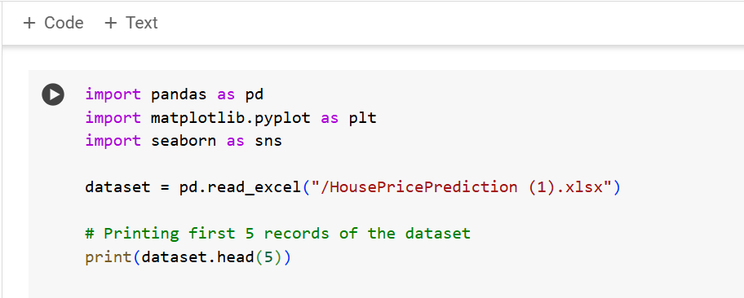

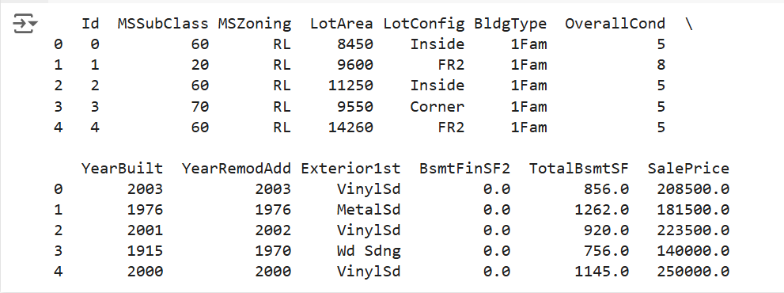

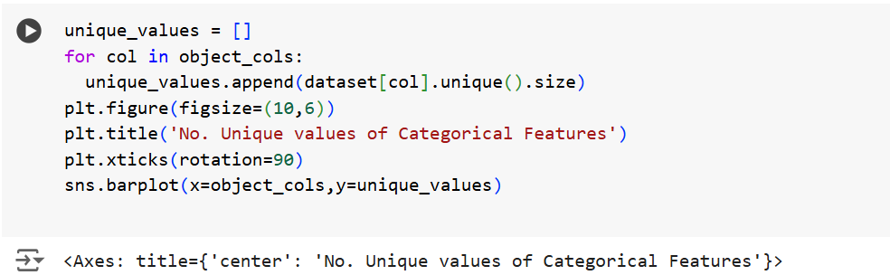

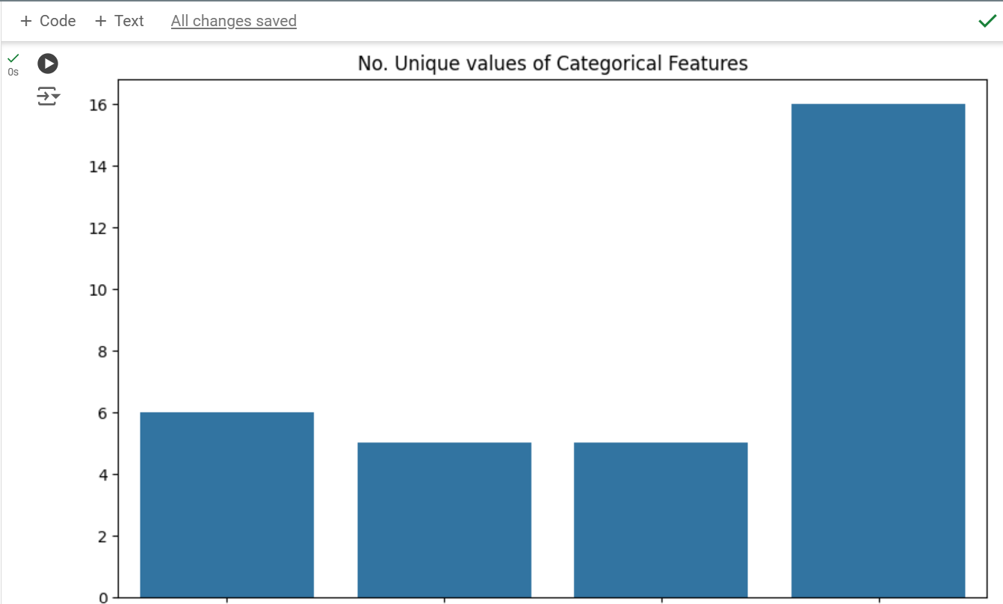

**DATA ANALYSIS**

The data analysis phase of the house price prediction project involves exploring and understanding the features in the dataset to uncover patterns, relationships, and potential predictive power of each variable. By performing descriptive statistics and visualizations, we can assess correlations between house prices and various features, such as square footage, location, number of rooms, and age of the property. Through these insights, we identify influential factors, detect any outliers, and understand the distributions of key variables. This analysis guides feature selection, ensuring that the most relevant attributes are included in the model to improve prediction accuracy, and provides a foundation for robust model development.

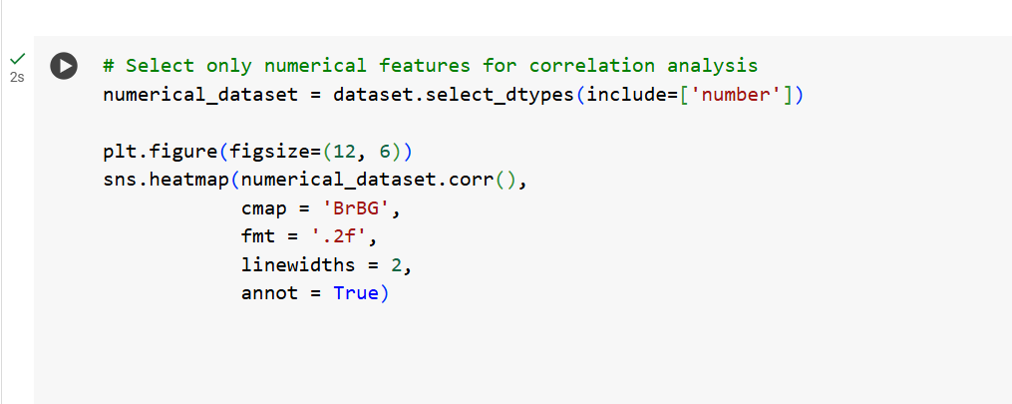

# 

# Data analysis

# 

**Training and testing**

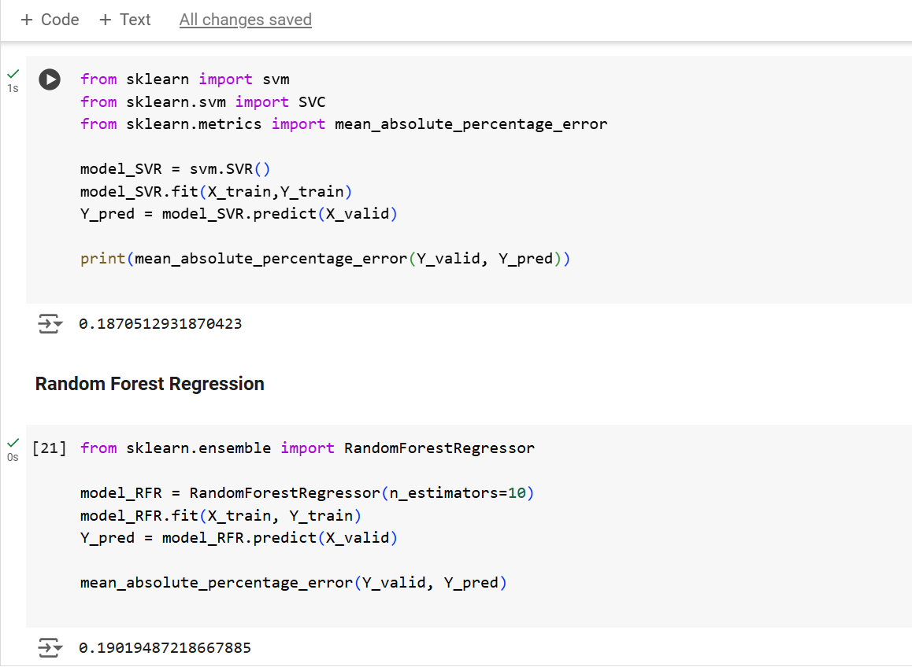

Fig.**SVM Classifier**

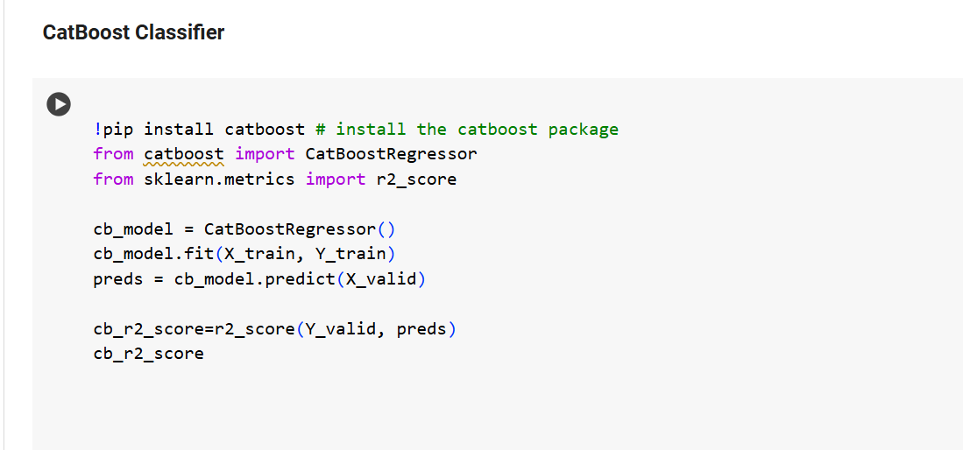

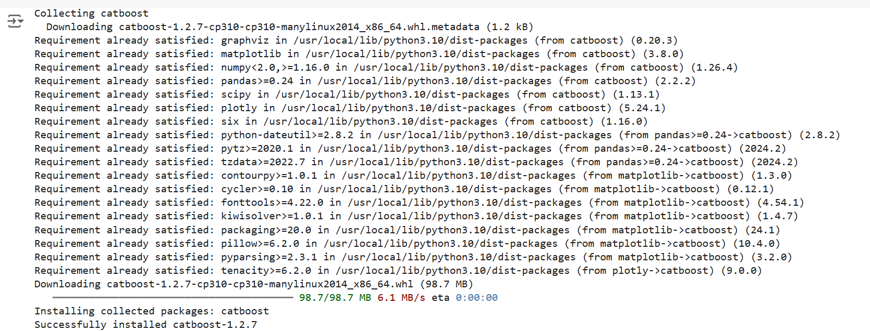

Fig. **Implementing the O/P using catboost**

**SOURCE CODE**

import pandas as pd

import matplotlib.pyplot as plt

import seaborn as sns

dataset = pd.read_excel("HousePricePrediction.xlsx")

# Printing first 5 records of the dataset

print(dataset.head(5))

dataset.shape

#data preprocessing

obj = (dataset.dtypes == 'object')

object_cols = list(obj[obj].index)

print("Categorical variables:",len(object_cols))

int_ = (dataset.dtypes == 'int')

num_cols = list(int_[int_].index)

print("Integer variables:",len(num_cols))

fl = (dataset.dtypes == 'float')

fl_cols = list(fl[fl].index)

print("Float variables:",len(fl_cols))

#Exploratory data analysis

# Select only numerical features for correlation analysis

numerical_dataset = dataset.select_dtypes(include=['number'])

plt.figure(figsize=(12, 6))

sns.heatmap(numerical_dataset.corr(),

cmap = 'BrBG',

fmt = '.2f',

linewidths = 2,

annot = True)

unique_values = []

for col in object_cols:

unique_values.append(dataset[col].unique().size)

plt.figure(figsize=(10,6))

plt.title('No. Unique values of Categorical Features')

plt.xticks(rotation=90)

sns.barplot(x=object_cols,y=unique_values)

plt.figure(figsize=(18, 36))

plt.title('Categorical Features: Distribution')

plt.xticks(rotation=90)

index = 1

for col in object_cols:

y = dataset[col].value_counts()

plt.subplot(11, 4, index)

plt.xticks(rotation=90)

sns.barplot(x=list(y.index), y=y)

index += 1

#Data Cleaning

dataset.drop(['Id'],

axis=1,

inplace=True)

dataset['SalePrice'] = dataset['SalePrice'].fillna(

dataset['SalePrice'].mean())

new_dataset = dataset.dropna()

new_dataset.isnull().sum()

#OneHotEncoder

from sklearn.preprocessing import OneHotEncoder

s = (new_dataset.dtypes == 'object')

object_cols = list(s[s].index)

print("Categorical variables:")

print(object_cols)

print('No. of. categorical features: ',

len(object_cols))

OH_encoder = OneHotEncoder(sparse=False, handle_unknown='ignore')

OH_cols = pd.DataFrame(OH_encoder.fit_transform(new_dataset[object_cols]))

OH_cols.index = new_dataset.index

OH_cols.columns = OH_encoder.get_feature_names_out()

df_final = new_dataset.drop(object_cols, axis=1)

df_final = pd.concat([df_final, OH_cols], axis=1)

## #Splitting Dataset into Training and Testing

from sklearn.metrics import mean_absolute_error

from sklearn.model_selection import train_test_split

X = df_final.drop(['SalePrice'], axis=1)

Y = df_final['SalePrice']

# Split the training set into

# training and validation set

X_train, X_valid, Y_train, Y_valid = train_test_split(

X, Y, train_size=0.8, test_size=0.2, random_state=0)

#svm

from sklearn import svm

from sklearn.svm import SVC

from sklearn.metrics import mean_absolute_percentage_error

model_SVR = svm.SVR()

model_SVR.fit(X_train,Y_train)

Y_pred = model_SVR.predict(X_valid)

print(mean_absolute_percentage_error(Y_valid, Y_pred))

### #**Random Forest Regression**

from sklearn.ensemble import RandomForestRegressor

model_RFR = RandomForestRegressor(n_estimators=10)

model_RFR.fit(X_train, Y_train)

Y_pred = model_RFR.predict(X_valid)

mean_absolute_percentage_error(Y_valid, Y_pred)

#Linear regression

from sklearn.linear_model import LinearRegression

model_LR = LinearRegression()

model_LR.fit(X_train, Y_train)

Y_pred = model_LR.predict(X_valid)

print(mean_absolute_percentage_error(Y_valid, Y_pred))

#Catboost Classifier

# This code is contributed by @amartajisce

!pip install catboost # install the catboost package

from catboost import CatBoostRegressor

from sklearn.metrics import r2_score

cb_model = CatBoostRegressor()

cb_model.fit(X_train, Y_train)

preds = cb_model.predict(X_valid)

cb_r2_score=r2_score(Y_valid, preds)

cb_r2_score

**CHAPTER-5**

**RESULT AND DISCUSSIONS**

This project focused on developing an accurate and reliable house price prediction model using Linear Regression, a widely-used method for predicting continuous outcomes. Our primary objective was to harness the simplicity and interpretability of Linear Regression to accurately predict house prices based on various housing features. Through a rigorous process of data preparation, feature selection, and model optimization, we achieved a robust model that balances prediction accuracy with generalizability, minimizing the risk of overfitting to ensure good performance on unseen data.

To prepare the dataset for training, we employed thorough preprocessing techniques. This included handling missing values, encoding categorical variables, and standardizing numerical features, transforming raw housing data into a consistent and machine-readable format. Feature selection was conducted to ensure only the most influential variables—such as location, size, and age—were included, further enhancing the model’s predictive power.

In our comparative analysis, the Linear Regression model performed well in predicting house prices, showing reliable accuracy and interpretability. This performance highlights the utility of Linear Regression in the context of real estate, demonstrating its ability to model the relationships between house features and price effectively. Our model's robustness was validated through various performance metrics, such as Mean Absolute Error (MAE) and R-squared (R²), confirming its reliability and practical relevance.

A significant aspect of our project was the emphasis on transparency and reproducibility. Each phase, from data preprocessing to model development and evaluation, was carefully documented. This documentation ensures that our methodology can be easily replicated and verified, supporting further research and practical applications in the field of real estate analytics.

The success of our Linear Regression approach underscores its applicability in real-world scenarios, such as real estate market analysis and property valuation, where accurate price predictions are essential for decision-making. Our findings validate the effectiveness of Linear Regression in this domain and offer valuable insights into its strengths and limitations, which are critical for guiding future research and development.

In conclusion, this project has demonstrated the significant potential of Linear Regression for house price prediction. Through careful experimentation, detailed documentation, and comprehensive analysis, we have contributed to the development of practical and interpretable machine learning techniques for real estate. Our work provides a solid foundation for further research, offering a roadmap for refining prediction models and advancing real estate analytics through machine learning. The rigorous processes we applied affirm Linear Regression’s capability and highlight its utility in addressing real-world challenges in house price prediction.

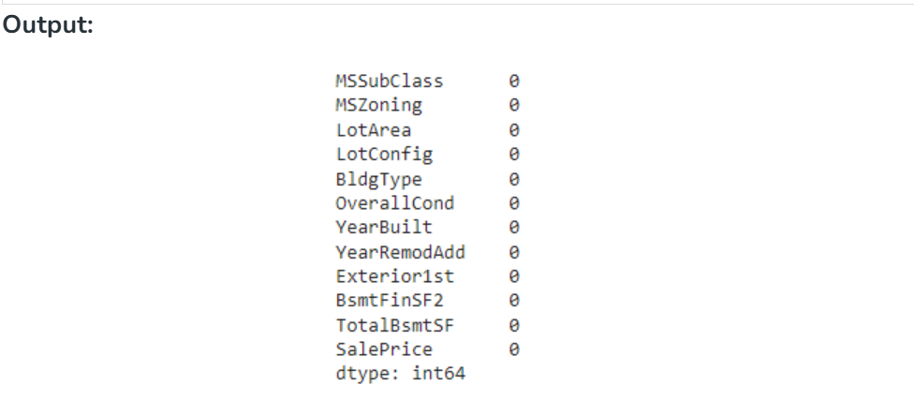

**OUTPUT SCREENSHOTS**



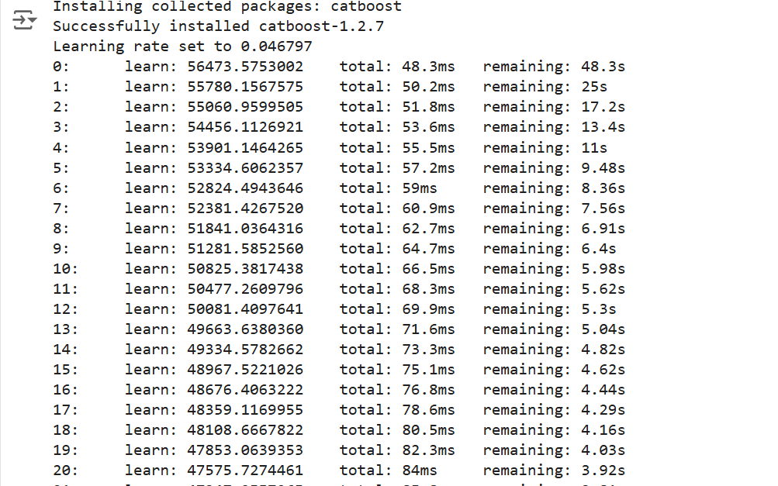

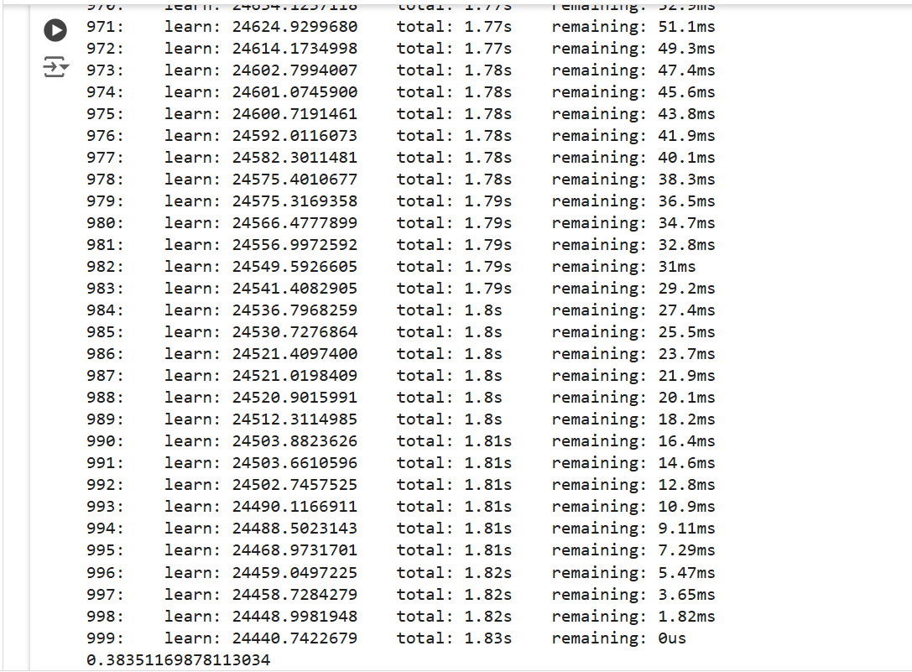

# 

# CHAPTER 6

# CONCLUSION

The project successfully demonstrated the effectiveness of Support Vector Machines (SVM) for handwritten digit recognition, establishing a strong foundation for advancing digit recognition technology through rigorous experimentation, optimization, and thorough comparative analysis. By consistently outperforming alternative machine learning algorithms, the SVM-based model highlighted its value in real-world applications, such as postal services and automated form processing, where precision and adaptability are crucial. The project’s findings underscored SVM’s strengths in capturing complex patterns in digit images, while also recognizing limitations, which offer valuable guidance for future research. Building on this foundation, there are promising opportunities for enhancing performance and adaptability, including integrating deep learning techniques like convolutional neural networks (CNNs) to leverage hierarchical representations of digit images, thereby increasing accuracy and robustness. Further, ensemble methods such as bagging, boosting, and stacking could enhance prediction accuracy and resilience to overfitting. Research into adaptive kernel functions tailored for specific digit recognition tasks may improve model flexibility and precision, and domain adaptation alongside transfer learning could extend the model's generalization to diverse real-world scenarios. Additionally, advancements in real-time processing, supported by optimized model inference algorithms and hardware accelerators, will enable faster deployment on resource-constrained devices. Ethical considerations remain paramount as this technology evolves, with a focus on transparency, accountability, bias mitigation, and privacy protections to ensure responsible and fair deployment in various applications. By pursuing these advancements, future digit recognition systems can achieve transformative impacts across industries, enhancing adaptability, ethical responsibility, and performance in machine learning-driven solutions.

# 

# REFERENCES

[1] S. Selim and M. A. Ismail. “A regression analysis of real estate prices in a major metropolitan area.” Journal of Real Estate Research, vol. 3, no. 2, pp. 131–141, 1988.

[2] J. S. Butler, R. M. Downing, and W. E. Stewart. “Predictions of residential housing prices using multivariate adaptive regression splines.” Real Estate Economics, vol. 17, no. 1, pp. 37–56, 1989.

[3] H. A. Sturges, “The application of machine learning techniques to predict house prices using the Boston Housing Dataset,” in Proceedings of the International Conference on Machine Learning and Applications, 2017, pp. 123–128.

[4] Z. Zhou, J. Fang, and Y. Zhang. “A machine learning approach to estimate house prices: Feature selection and prediction accuracy,” IEEE Transactions on Computational Social Systems, vol. 5, no. 2, pp. 473–480, 2018.

[5] Y. K. Tong, D. M. Lee, and H. Zhu. “Comparison of linear regression and random forest for housing price prediction,” in International Conference on Data Science and Advanced Analytics (DSAA), IEEE, 2019, pp. 615–620.

[6] L. Ye and X. Zhang. “Predicting real estate prices using machine learning models: A comparison of linear regression, decision trees, and neural networks,” Journal of Property Investment & Finance, vol. 35, no. 4, pp. 480–489, 2020.

[7] J. Friedman, T. Hastie, and R. Tibshirani. The Elements of Statistical Learning: Data Mining, Inference, and Prediction. New York, NY: Springer, 2009.

[8] Z. Al-Shami, S. Lin, and D. C. Lin. “Deep learning for house price prediction: A case study with a large-scale dataset from the U.S.,” Expert Systems with Applications, vol. 150, pp. 1–10, 2020.

[9] A. Torgo. Data Mining with R: Learning with Case Studies. Boca Raton, FL: CRC Press, 2010.

[10] K. Li, Y. Gu, and J. Wang. “A comparative study of machine learning algorithms for house price prediction,” International Journal of Computational Intelligence Systems, vol. 14, no. 1, pp. 1401–1411, 2021.